- Logo: 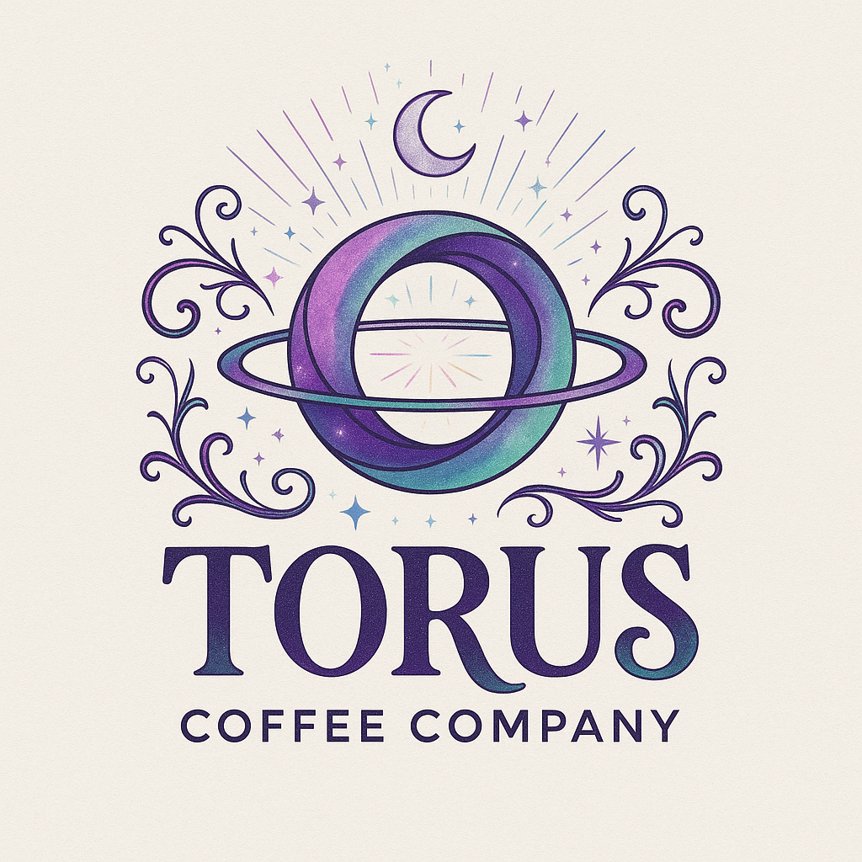
- Business Name – Torus Coffee Company
- Tagline (Optional) – Stay Curious. Stay Crunchy. Stay Cosmic.
- Website – https://www.toruscoffeecompany.com/
- Contact Name: Sara-Jane Shelvock, CEO
- Preferred Email Address: admin@toruscoffeecompany.com
- Phone Number: (319)-471-3383
- Social Media handles (even just the ones you want to include, like:)
  - Facebook: @TorusCoffeeCompany
  - X (Twitter): @TorusCoffee
  - YouTube: @TorusCoffeeCompany
  - TicTok: @toruscoffeecompany
  - Pinterest @TorusCoffee
- Do you want a QR code included that links to your website? Yes. https://www.toruscoffeecompany.com/
- Do you prefer the card to be colorful or black & white so your daughter can color it in like the signs? A version of both colorful and Black and white.

